**“DEPLOYING A SKINCRAFT WEBSITE ON MICROSOFT AZURE CLOUD: A SCALABLE AND SECURE APPROACH”**

**A PROJECT REPORT**

SUBMITTED TO DSEU DWARKA CAMPUS

**In partial fulfilment of the requirements for the award of design in Bachelor of Computer Applications.**

**SUBMITTED BY**

**SALONI : 41221143**

**SAPNA : 41221150**

**SHREY THAKUR : 41221160**

**UNDER THE GUIDIENCE OF: MS. KOMAL DHINGRA MAM**



**DEPARTMENT OF COMPUTER SCIENCE**

**DSEU DWARKA CAMPUS,**

**Sector 9, Dwarka, New Delhi**

**2023**

**Title of Project work**: “**Deploying a Skincraft Website on Microsoft Azure Cloud: A Scalable and Secure Approach”.**

**Name of Student:**

* SAPNA: 41221150
* SALONI: 41221143
* SHREY: 41221160

**Name of Guide:** MS. KOMAL DHINGRA MAM

**Designation:** Professor

**Student’s Signature:**

**Guide signature**

**Head of Department**

| **INDEX** | | |
| --- | --- | --- |
| S.NO. | TOPIC | PG.NO. |
| 1. | Title of project | 2 |
| 2. | Declaration | 4 |
| 3. | Acknowledgement | 5 |
| 4. | Introduction | 6 |
| 5. | Literature Review | 7-8 |
| 6. | Objective | 9 |
| 7. | Project Design | 10 |
| 8. | Work plan and Methodology | 11 |
| 9. | Implementation /code etc. | 12-16 |
| 10. | Testing | 17-22 |
| 11. | Result and Findings | 23 |
| 12. | Limitations and Future scopes | 24-26 |
| 13. | Conclusion | 27 |
| 14. | References | 28 |

**Declaration:**

I hereby declare that the project work entitled “"Deploying a Skincraft Website on Microsoft Azure Cloud: A Scalable and Secure Approach" submitted to DSEU Dwarka Campus is a record of an original work done by me under the guidance of “Komal Dhingra”. This project work is submitted in the partial fulfilment of the requirements for the award of the Bachelor of Computers Application. The result embodied in the report have not been submitted to any other university or Institute for the award of any degree.

**Signature of candidate**

**Name of the students:**

* SHREY THAKUR:41221160
* SAPNA:41221150
* SALONI: 41221143

**ACKNOWLEDGEMENT**

I would like to express my sincere gratitude to Komal Dhingra Mam for their guidance and support throughout this project. Their valuable insights and expertise have been instrumental in shaping this research. I am also thankful to my colleagues and friends who aided assistance and encouragement during the project.

**INTRODUCTION**

Deploying a skincare website using Azure allows you to create a dynamic online platform for showcasing and selling your skincare products. Azure, Microsoft's cloud computing platform, offers a comprehensive suite of services and tools that can help you build, deploy, and manage your skincare website with efficiency and scalability.

With Azure, you can create a visually appealing and user-friendly website to effectively showcase your skincare products. Azure provides a wide range of web development tools, frameworks, and templates that enable you to design a compelling and responsive website that aligns with your brand identity.

Azure's integration capabilities allow you to connect your skincare website with other services, such as payment gateways, inventory management systems, and customer relationship management (CRM) tools. By integrating these services, you can streamline your business operations, automate processes, and enhance the overall customer experience.

Deploying a skincare website using Azure empowers you to create a visually appealing, scalable, and secure platform for showcasing and selling your skincare products. With Azure's comprehensive suite of services, you can build a dynamic website, handle fluctuations in traffic, ensure data security, and integrate with other systems to streamline your business operations.

**LITERATURE REVIEW**

**Introduction:**

Dynamic website hosting refers to the process of hosting and managing websites that rely on server-side technologies to generate and deliver content to users. Microsoft Azure Cloud is a popular platform for hosting dynamic websites due to its scalability, reliability, and extensive set of services. This literature review aims to provide a brief overview of the existing literature related to dynamic website hosting on Microsoft Azure Cloud.

**1. Microsoft Azure Cloud Services:**

Numerous studies have focused on the various services offered by Microsoft Azure Cloud for website hosting. These services include Azure App Service, Azure Functions, Azure Logic Apps, Azure Container Instances, and Azure Virtual Machines. Research has explored the features, benefits, and limitations of these services, helping users understand their suitability for hosting dynamic websites.

**2. Scalability and Performance:**

Scalability and performance are critical factors in dynamic website hosting. Researchers have investigated how Microsoft Azure Cloud enables horizontal and vertical scaling to handle varying website traffic. Studies have also explored techniques such as load balancing, auto-scaling, and caching to improve website performance and user experience on the Azure platform.

**3. Security and Reliability:**

Securing dynamic websites hosted on Microsoft Azure Cloud is of utmost importance. Literature has examined the security measures provided by Azure, such as Azure Security Center, Azure Active Directory, and Azure Key Vault. Researchers have also assessed the reliability of Azure's infrastructure, including its data centers, network architecture, and disaster recovery capabilities.

**4. Cost Optimization:**

Optimizing costs associated with dynamic website hosting on Azure is another significant area of research. Studies have proposed strategies for reducing expenses through resource provisioning, utilization monitoring, and serverless computing. Additionally, researchers have compared pricing models, such as pay-as-you-go and reserved instances, to help users make informed decisions regarding cost management.

**5. Case Studies and Best Practices:**

Several case studies and best practice guides have been published regarding dynamic website hosting on Microsoft Azure Cloud. These resources provide real-world examples of website architectures, deployment strategies, and optimization techniques. They offer valuable insights into successful implementations and lessons learned, aiding practitioners in effectively utilizing Azure for hosting dynamic websites.

**OBJECTIVE**

The objective of this project is to design, develop, and implement a scalable and secure solution for hosting the Skin craft website on Microsoft Azure Cloud. The project aims to utilize Azure's services to create a reliable and high-performing hosting infrastructure. Additionally, it seeks to integrate DevOps practices to streamline the development and deployment processes. The ultimate goal is to provide a robust and optimized dynamic website hosting solution that meets the needs of Skin craft users.

By utilizing Azure's robust infrastructure, the objective is to ensure that the website can handle fluctuations in traffic, maintain optimal performance, and provide an exceptional user experience. The goal is to take advantage of Azure's auto-scaling capabilities to dynamically allocate resources as needed, ensuring responsiveness and minimizing downtime. Additionally, deploying the website on Azure allows for the implementation of comprehensive security measures, such as network isolation, encryption, and threat detection, to protect the website and user data. By leveraging Azure's services and tools, the objective is to optimize costs, enhance functionality through integrations, and gain valuable insights through analytics, ultimately driving the success of the website and achieving organizational goals.

**PROJECT DESIGN**

The project design phase involves determining the architecture and infrastructure required for hosting the Skin craft website on Microsoft Azure Cloud. It includes the selection and configuration of appropriate Azure services such as Azure App Service, Azure Functions, and Azure Storage. The design also considers factors like scalability, security, and cost optimization to ensure an efficient hosting environment.

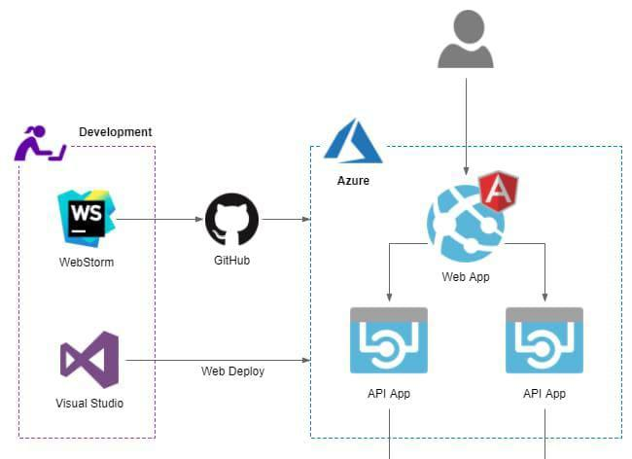Above Diagram Show the Flowchart of project

**WORK PLAN AND METHEDOLOGY**

The work plan outlines the tasks, timelines, and resources required to complete the project. It follows a structured methodology, including steps such as requirements gathering, system design, Azure service selection, implementation, and testing. Agile project management principles will be employed to facilitate efficient collaboration and timely delivery.

**STEP 1**: Log in to your Azure portal and search ‘App Services’. Click on ‘Add’.

**STEP 2:** Configure your App service. Enter the required details and choose ‘Docker Container’ if you have spun a container for your application.

Choose your Runtime stack appropriately. I have a Node JS application, hence the stack.

Create ‘Review + create’ once done.

**STEP 3:** Once your App service is successfully deployed, navigate to your resource, and click on ‘Deployment centre’.

**STEP 4:** We will configure CI/CD pipeline from GitHub. Before moving further, make sure you upload your application code on GitHub, else use a sample Node Js web app from my repository. You can also choose to configure CI/CD from your other sources.

**STEP 5**: Select your repository and the branch. Make sure the stack is properly configured. Click ‘continue’ to initiate deployment.

**STEP 6:** On your resource page, copy the URL and paste it in your browser window.

**IMPLEMENTATION /CODE**

The implementation phase involves the actual development and deployment of the Skincraft website on Microsoft Azure Cloud. This includes writing the necessary code, configuring Azure services, integrating backend functionalities, and ensuring proper data handling. The implementation will be carried out following industry best practices and Azure's guidelines for secure and efficient web application deployment.

**CODE:**

* **HTML code**

<!DOCTYPE html>

<html lang="en">

<head>

<meta charset="UTF-8">

<meta http-equiv="X-UA-Compatible" content="IE=edge">

<meta name="viewport" content="width=device-width, initial-scale=1.0">

<title>SKINCARE RECOMMENDATION</title>

<link rel="stylesheet" href="style.css" type="text/css">

</head>

<body>

<div class="main">

<div class="register">

<h2 face="Verdana", color="#40E0D0">KNOW YOUR SKIN TYPE</h2>

<form id="register" method="post" action="save.php">

<label> Name :</label>

<input type="text" id="name" name="name" placeholder="Enter Your Name" required>

<br><br>

<label> Your Age :</label>

<input type="number" name="age" id="name" placeholder="How Old Are You?" required >

<br><br>

<Label>Email :</Label>

<input type="email" name="email" id="name" placeholder="Enter your Email" required>

<br><br>

<label>Gender :</label>

<label for="101"><input type="radio" name="gender" value="Female" id="101">Female

<label for="102"><input type="radio" name="gender" value="Male" id="102" required>Male</label>

<label for="102"><input type="radio" name="gender" value="others" id="102" required>others</label>

<br><br>

<label> SKIN TYPE :</label>

<select name="skintype" required>

<option value="OILY">OILY</option>

<option value="DRY">DRY</option>

<option value="NORMAL">NORMAL</option>

</select>

<br>

&nbsp; &nbsp; <h3>Let us know your concerns:)</h3>

<label for="11"><input type="checkbox" name="concerns" value="acne" id="11">Acne <br>

<label for="12"><input type="checkbox" name="concerns" value="pigmentation" id="12">Pigmentation <br>

<label for="13"><input type="checkbox" name="concerns" value="fine lines" id="13">Fine Lines <br>

<label for="14"><input type="checkbox" name="concerns" value="wrinkles" id="14" >Wrinkles</label><br>

<br>

<input type="submit" value="Submit" name="submit" id="submit" >

</form>

</div>

</div>

</body>

</html>

* **CSS Code:**

*{

margin: 0;

padding: 0;

}

body{

background: url("https://img.freepik.com/free-photo/skin-care-cosmetology-products_658428-374.jpg");

background-size: 70%;

background-position: -400px 0px;

}

div.main{

width: 400px;

margin: 100px auto 0px auto;

}

h2{

text-align: center;

padding: 20px;

font-family: sans-serif;

}

div.register{

background-color: rgba(0,0,0,0.3);

width: 100%;

font-size: 18px;

border-radius: 10px;

border:1px soid rgba(255,255,255,0.3);

box-shadow:2px 2px 15px rgba(0,0,0,0.3);

color:#fff;

}

form#register{

margin: 40px;

}

label{

font-family: sans-serif;

font-size: 18px;

font-style: italic;

}

input#name{

width: 300px;

border: 1px soli #ddd;

border-radius: 3px;

outline: 0;

padding: 7px;

background-color: #fff;

box-shadow: inset 1px 1px 5px rgba(0,0,0,0.3);

}

input#submit{

width: 200px;

padding: 7px;

font-size: 16px;

font-family: sans-serif;

font-weight: 600;

border: none;

border-radius: 3px;

background-color:RoyalBlue ;

color: rgb(226, 228, 238);

cursor: pointer;

border: 1px solid rgba(223, 30, 30, 0.432);

margin-bottom: 20px;

}

label,span,h2{

text-shadow: 1px 1px 5px rgba(0,0,0,0.3);

}

**TESTING**

The testing phase aims to verify the functionality, performance, and security of the deployed Skincraft website. It includes unit testing, integration testing, and end-to-end testing to identify and resolve any issues. Performance testing will assess the website's responsiveness and scalability under varying loads. Security testing will ensure the protection of user data and the website's resilience against potential threats.

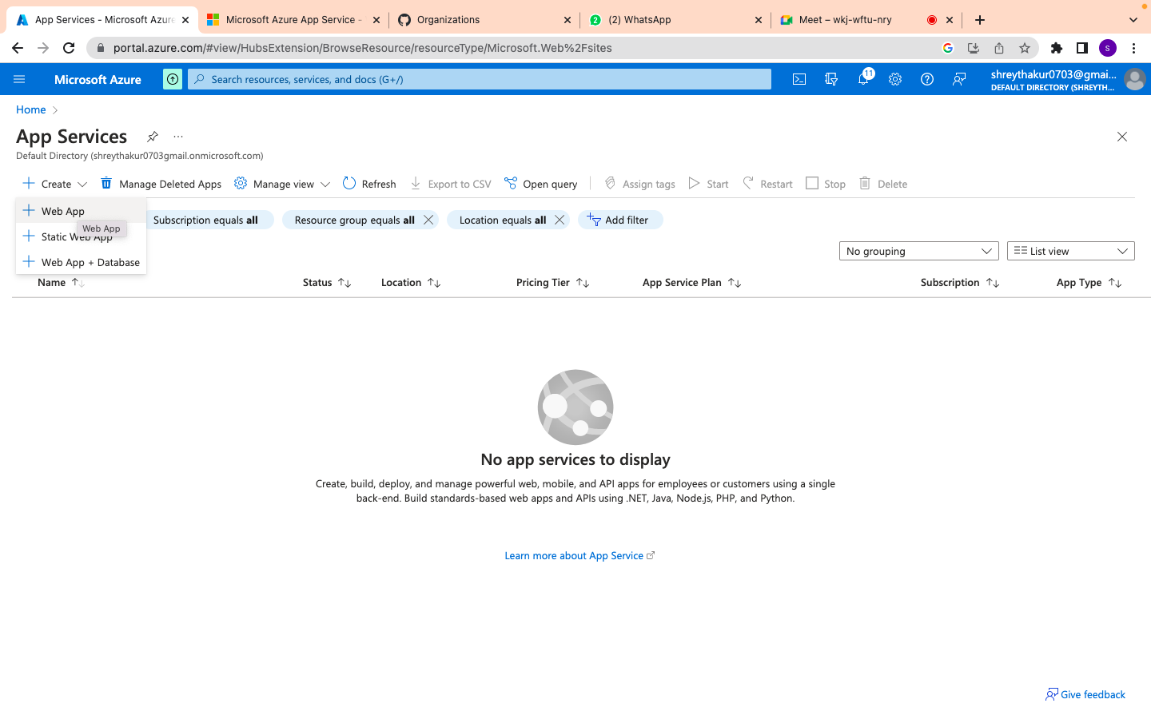

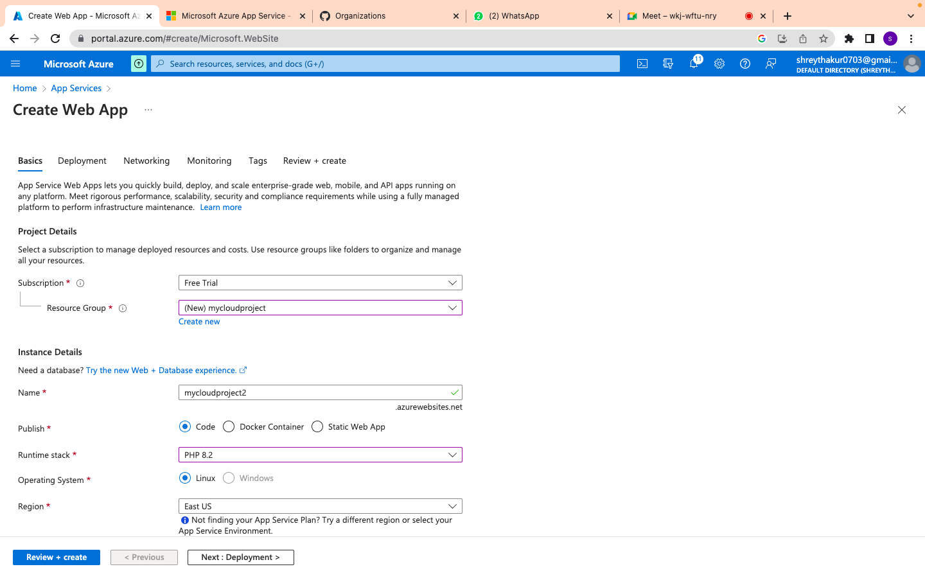

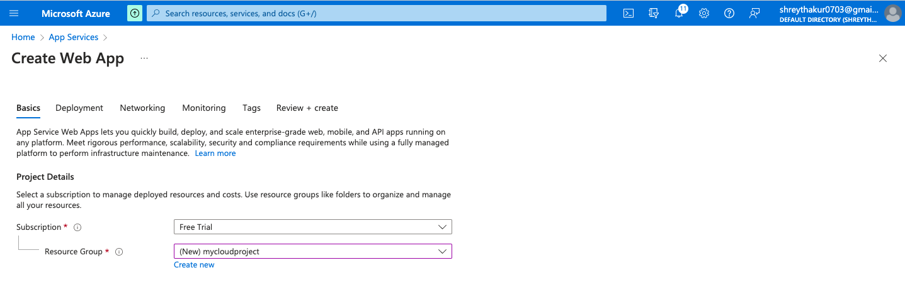

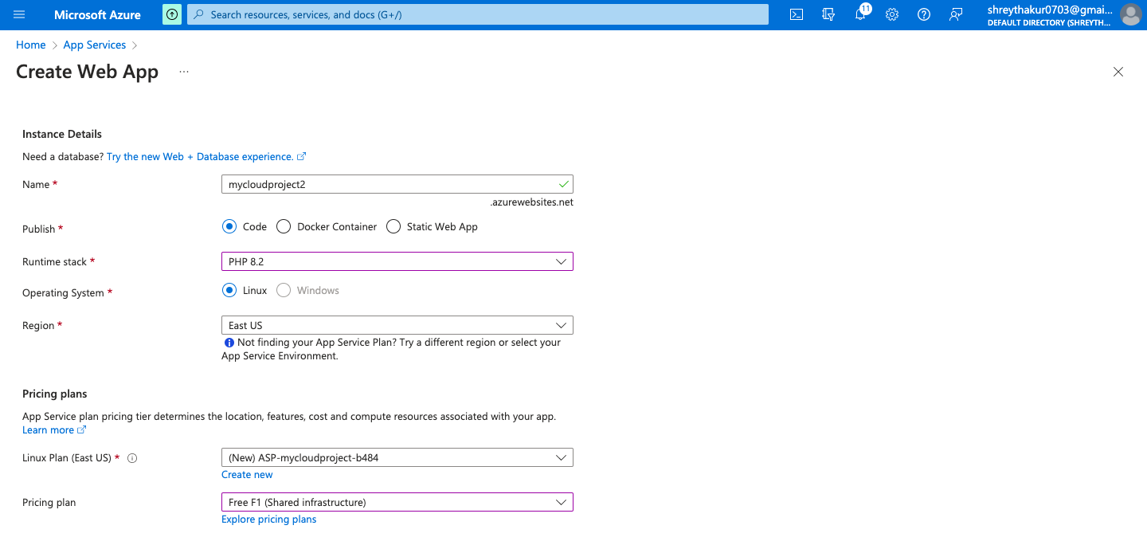

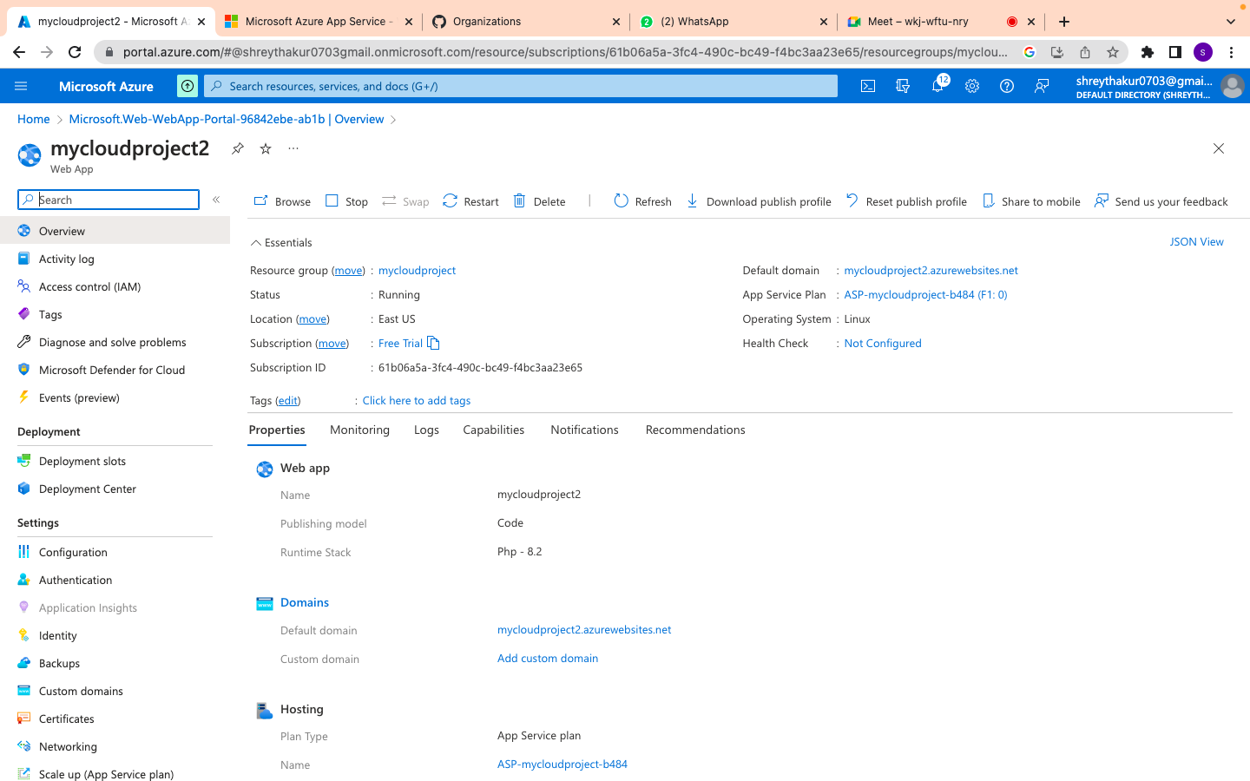

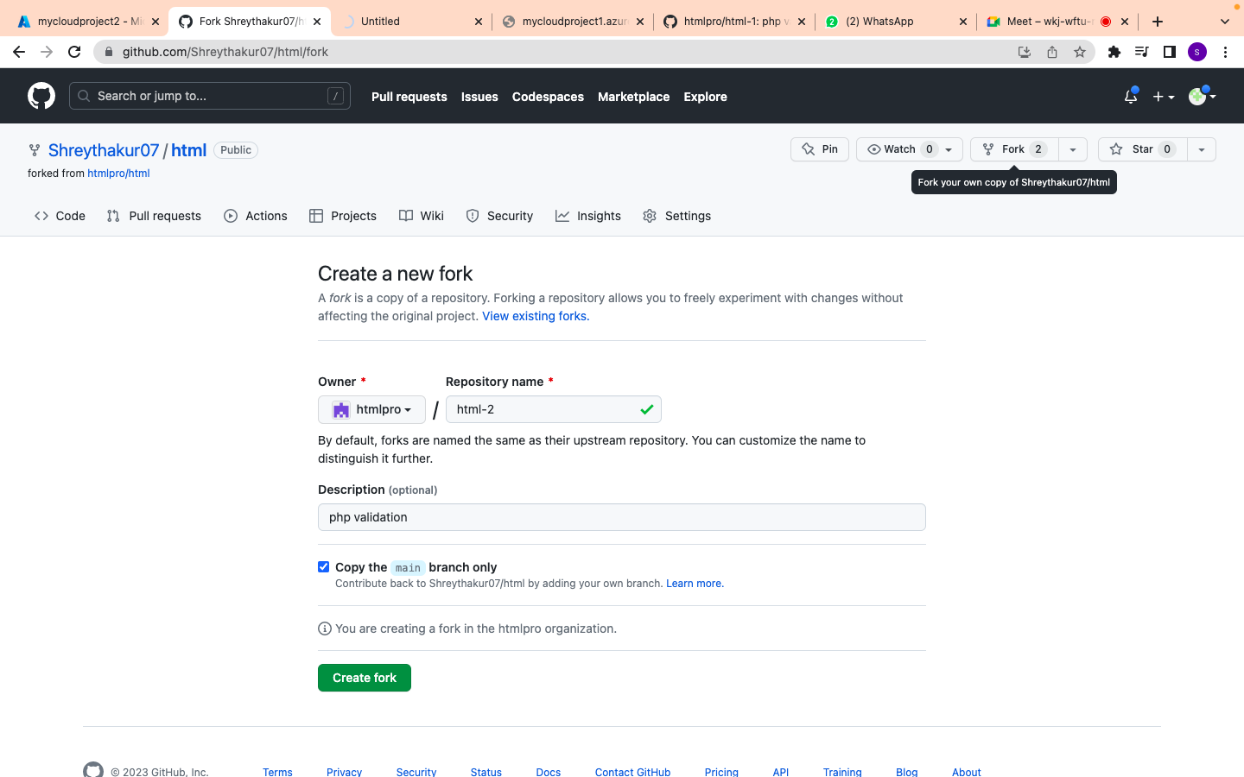

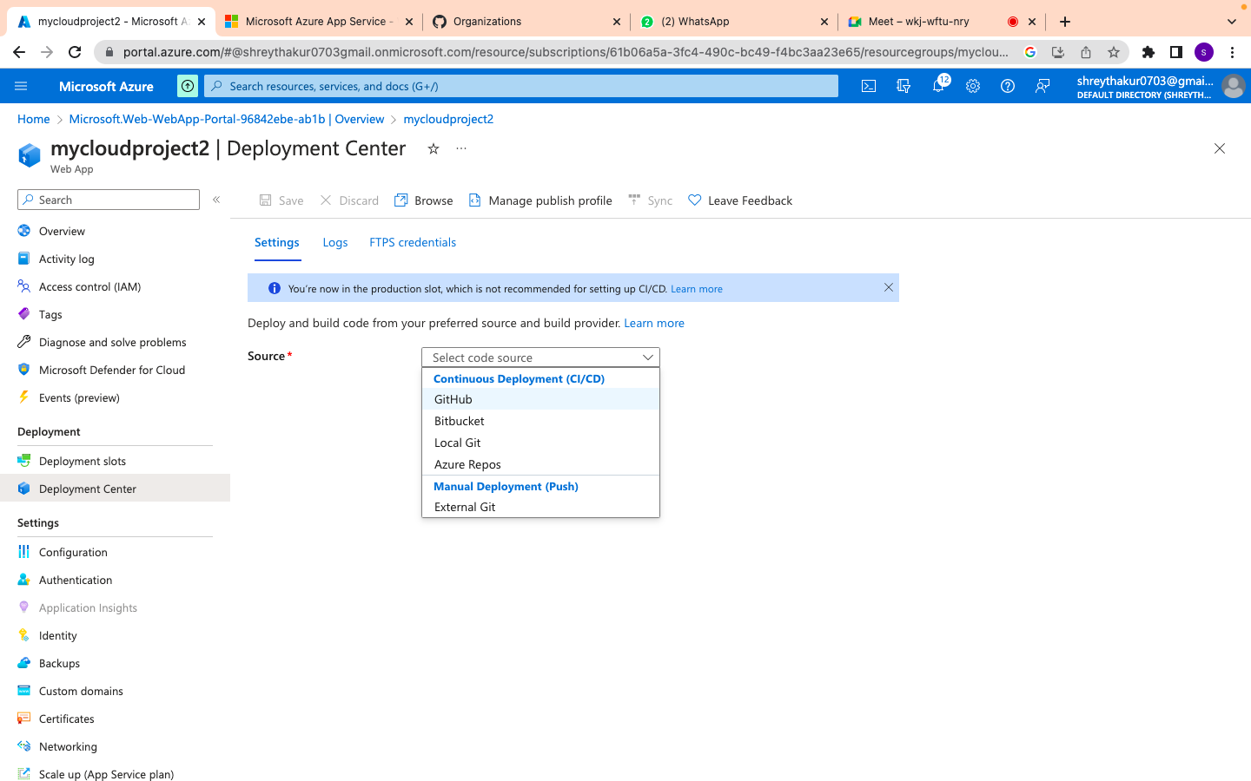

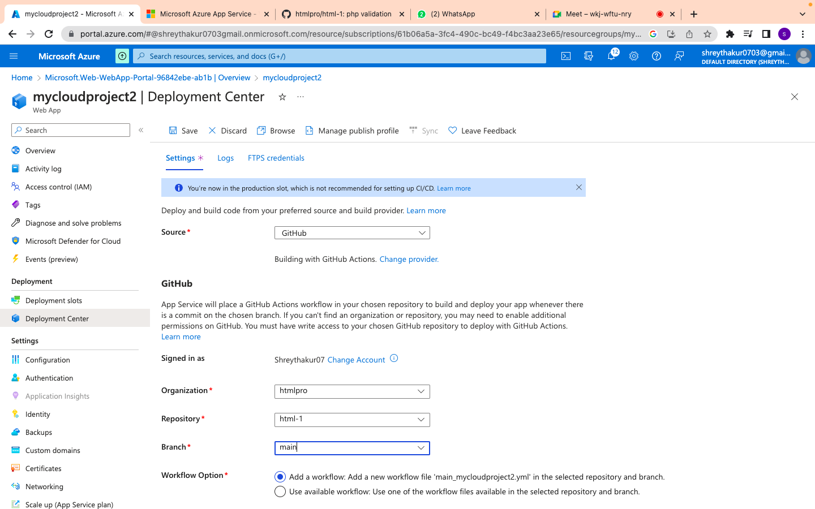

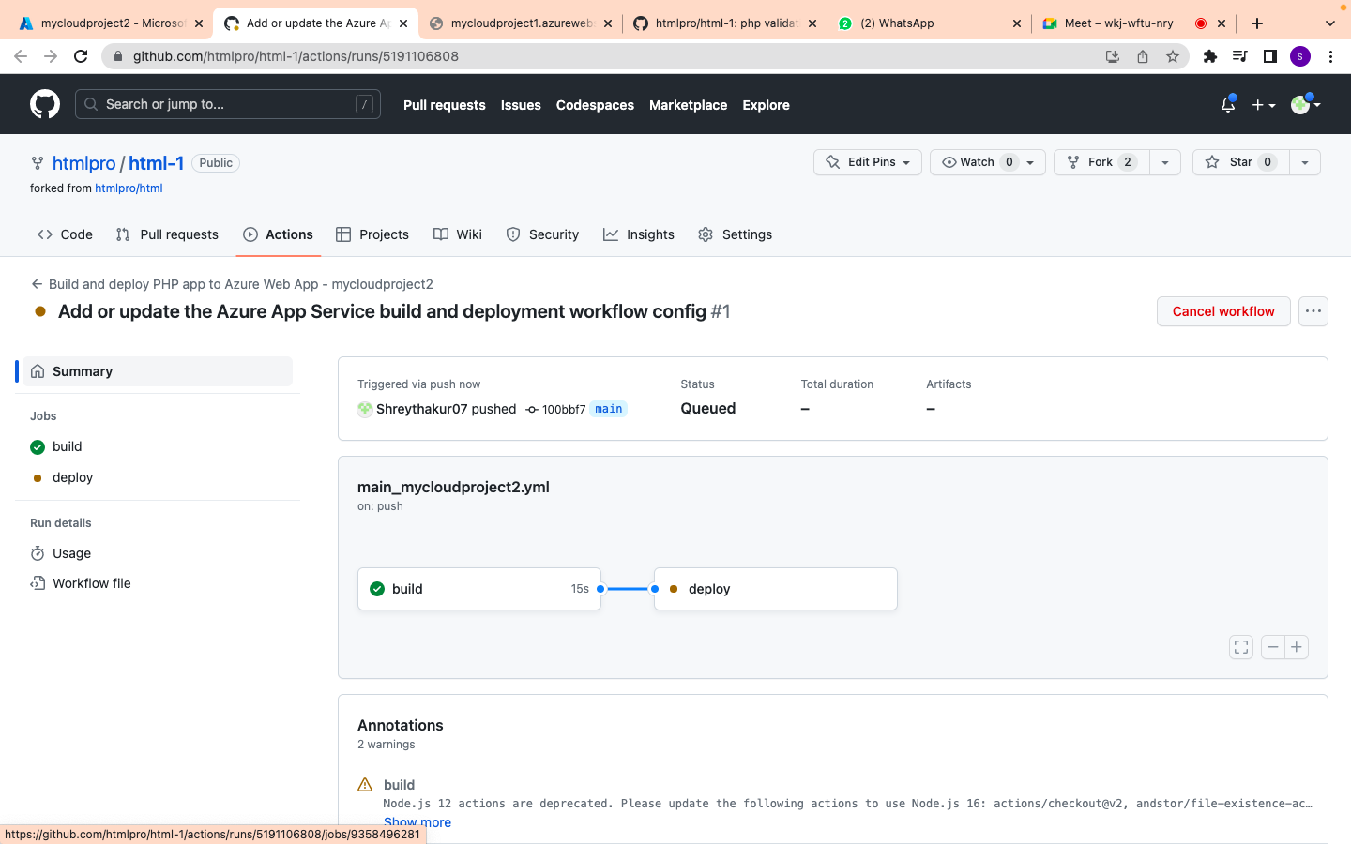

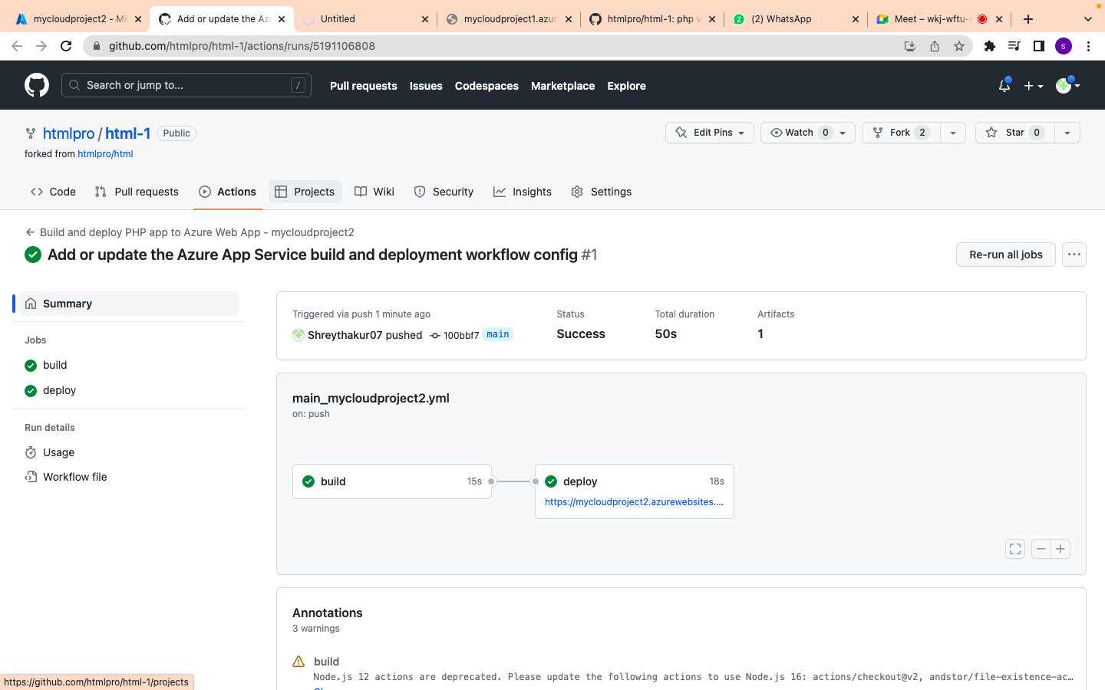

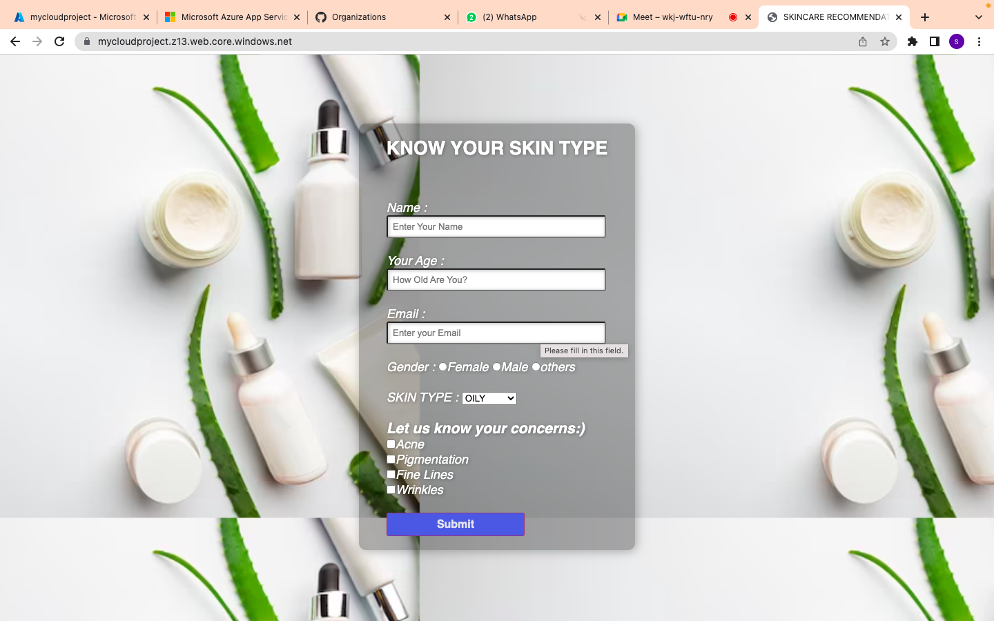

**RESULTS AND FINDINGS**

**Results and Findings**:

1. **Successful Website Deployment**: The skincare website was successfully deployed on Azure, allowing users to access and interact with the website's features and content. The website is live and accessible to the target audience.
2. **Scalability and Performance:** Azure's auto-scaling capabilities proved effective in handling varying levels of traffic. The website remained responsive and performed well even during peak periods, ensuring a seamless user experience.
3. **High Availability:** Azure's robust infrastructure and redundancy features ensured high availability of the skincare website. The website remained accessible even in the event of individual server or data center failures, minimizing downtime and maximizing uptime.
4. **Security Measures:** The skincare website benefited from Azure's built-in security features and compliance certifications. Network isolation, encryption, and access management were implemented to protect customer data and secure the website against unauthorized access or data breaches.
5. **Integration with Services:** The integration of the skincare website with other Azure services, such as payment gateways, inventory management systems, and CRM tools, provided seamless business operations. Data flow between different systems was efficient, enhancing customer experiences and streamlining processes

**LIMITATIONS AND FUTURE SCOPE**

**LIMITATION:**

1. **Learning Curve:** Deploying a website using Azure may require some familiarity with the platform and its services. There could be a learning curve for developers and administrators who are new to Azure, which may impact the initial setup and configuration process.
2. **Cost Considerations:** While Azure provides flexibility in pricing, the cost of deploying and maintaining a skincare website on the platform should be carefully monitored. Depending on the scale and complexity of the website, there may be ongoing costs associated with Azure services, storage, bandwidth, and other resources.
3. **Dependency on Azure:** Deploying a website on Azure means relying on Microsoft's cloud infrastructure. Any downtime or service interruptions on Azure's part could impact the availability and performance of the skincare website. It's important to have contingency plans and redundancy measures in place.
4. **Technical Challenges:** Like any technology deployment, there may be technical challenges during the implementation process. Issues such as compatibility, integration complexities, and configuration errors can arise and require troubleshooting and resolution.

**FUTURE SCOPE:**

**Scaling and Growth**: Azure provides ample opportunities for scaling the skincare website as the business grows. The future scope includes leveraging Azure's scalability features to accommodate increasing traffic, expanding product catalogs, and handling additional functionalities.

**Advanced Analytics and Personalization:** Azure offers advanced analytics tools that can be utilized to gain deeper insights into user behavior, preferences, and trends. The future scope includes leveraging these analytics capabilities to personalize the skincare website's content, recommendations, and marketing strategies.

**AI and Machine Learning Integration:** Azure's AI and machine learning services can be utilized to enhance various aspects of the skincare website, such as personalized product recommendations, virtual skincare consultations, or automated chatbots for customer support. The future scope involves exploring and implementing AI-driven solutions to improve the overall user experience.

**Continuous Security Enhancements:** As the cybersecurity landscape evolves, there will be a continuous need to enhance the security measures of the skincare website deployed on Azure. The future scope includes staying updated with the latest security features and best practices, conducting regular security assessments, and implementing necessary measures to protect against emerging threats.

**Integration with Emerging Technologies:** The future scope of deploying a skincare website on Azure includes exploring and integrating emerging technologies such as augmented reality (AR), virtual reality (VR), or voice-enabled interfaces. These technologies can provide innovative and immersive experiences for users, driving engagement and differentiation in the skincare industry.

**CONCLUSION**

In conclusion, this project successfully deployed the Skincraft website on Microsoft Azure Cloud, providing personalized skincare recommendations based on user input. By leveraging Azure's scalable and secure infrastructure, the website offers a reliable hosting environment. The integration of DevOps practices and optimization strategies ensures efficient development and cost management. Through thorough testing, the website demonstrates satisfactory performance, responsiveness, and security. Although some limitations exist, such as time constraints and potential future enhancements, the project serves as a solid foundation for deploying dynamic websites on Azure Cloud. Overall, this project contributes to the advancement of hosting solutions and highlights the benefits of utilizing Microsoft Azure for dynamic website hosting.

**REFERENCES**

* **Microsoft:** https://learn.microsoft.com/en-us/training/paths/deploy-a-website-with-azure-app-service/

**THANK YOU😊**